LA MULTI ANI 2018-LA MULTI ANI"VASILE-GOLDIS"

REVEDERE 20 DE ANI PROMOTIA DE MEDICINISTI

1998



Anul acesta aniversam 20 ani de la absolvirea Facultatii de Medicina generala "Vasile Goldis "Arad Promotia 1998
Am bucuria si placerea sa va anunt revederea noastra care va avea loc la Arad in data de vineri 21 septembrie 2018.(in timp util va vom anunta programul si ora revederii)

Cu respect va rog sa schimbati intre voi propuneri, dorinte,idei de modul in care ati dori sa decurga aceasta noua intalnire,dialog ce poate avea loc pe WathsApp,moderator grup Colegul nostru Dr.Constantin Alexandru care are numarul de telefon 0723539201.Cred ca ar fi bine ca pana la sfarsitul lunii februarie 2018 sa ne decidem cine doreste cu adevarat sa participe la revedere si sa anunte daca vine singur sau cu sotul / sotia.
Data revederii nu poate fi schimbata deoarece colegele din Arad au inceput demersurile pentru ziua de 21 septembrie 2018.

Pentru WathsApp iti dau telefonul sotiei 0740367954-Adela Mariana Leoveanu.

PENTRU ACEASTA VA PROPUN SA ANUNTAM IN TIMP UTIL OBTIUNEA NOASTRA

Persoane de contact Revederea de 20 de ani absolvire medicina:
1-Dr.Leoveanu T.Ionut Horia 0740065182
2-Dr.Constantin Alexandru 0723539201
3-Dr.Cojocea Florentina 0722458640
4-Dr.Carmen Ferche 0771594676
5-Dr.Raluca Gherasim 0744843785

CU DRAG FOSTUL COLEG DE FACULTATE
LEOVEANU T. IONUT - HORIA STR.LUCIAN BLAGA
TELEFON NR. 2, ETAJ 1, AP. 4, BRASOV acasa-0268/411076,mobil 0740065182 JUDETUL BRASOV
e-mail iLeoveanu@yahoo.com COD 500008

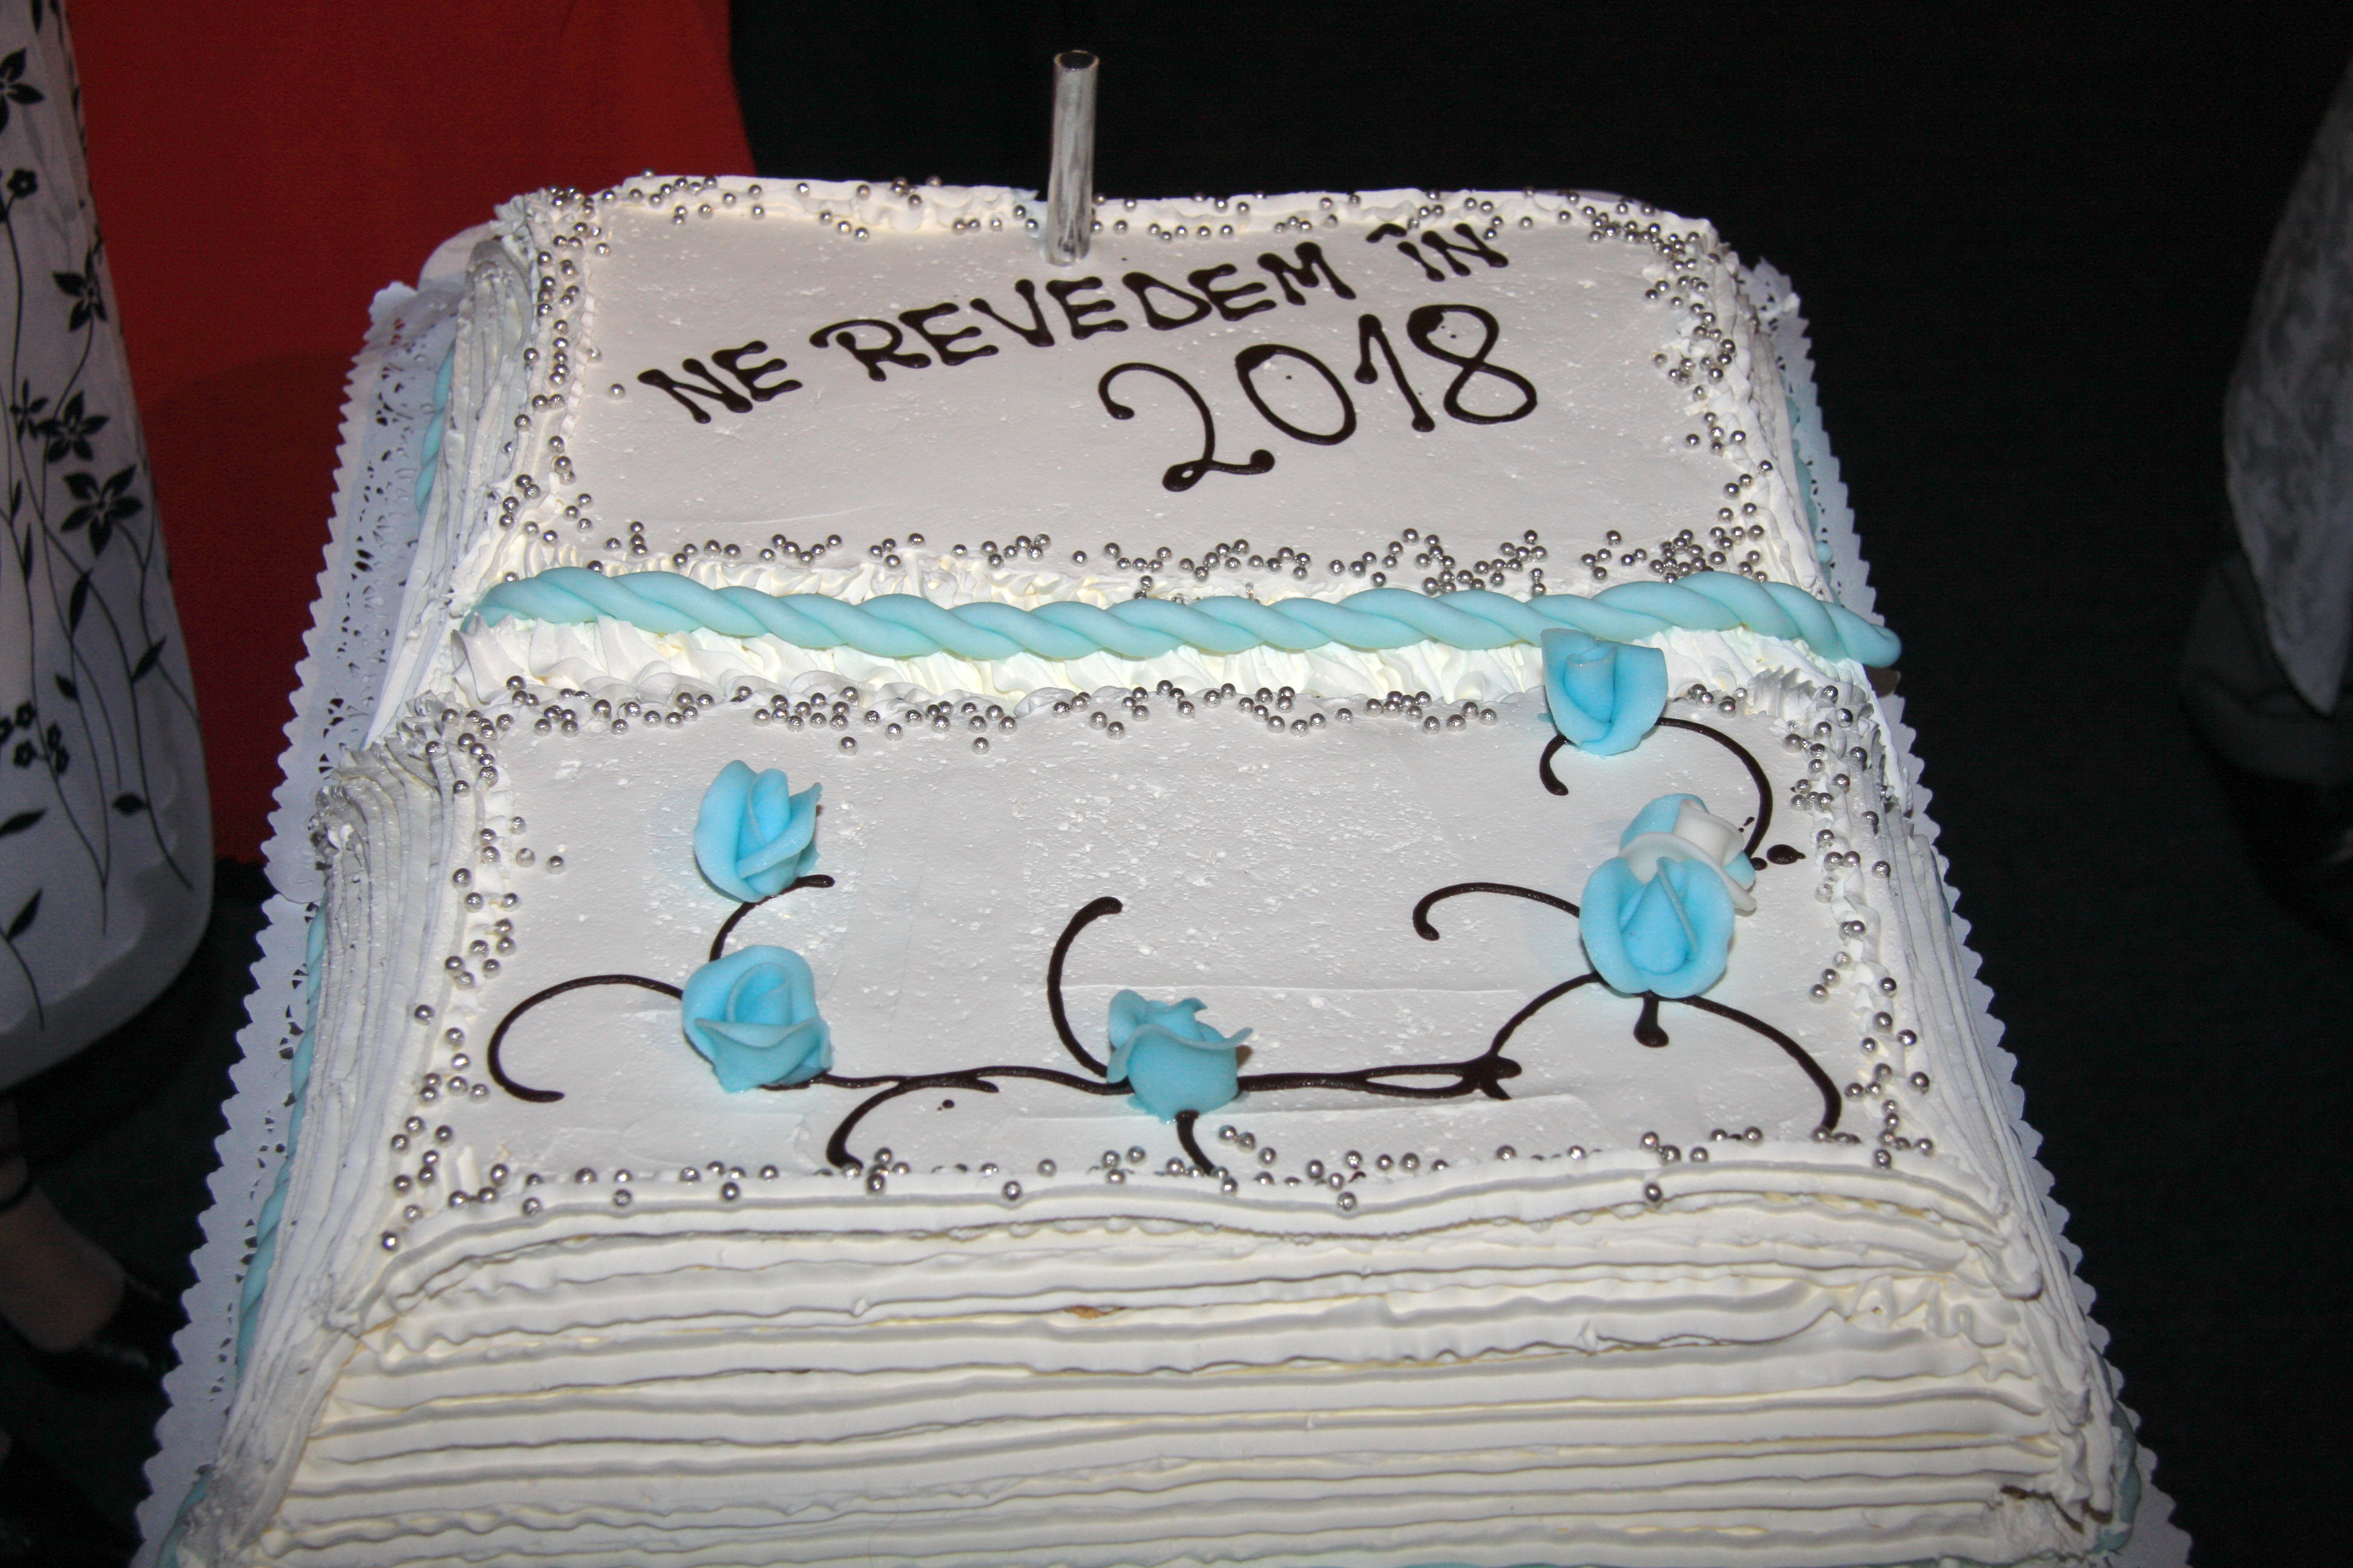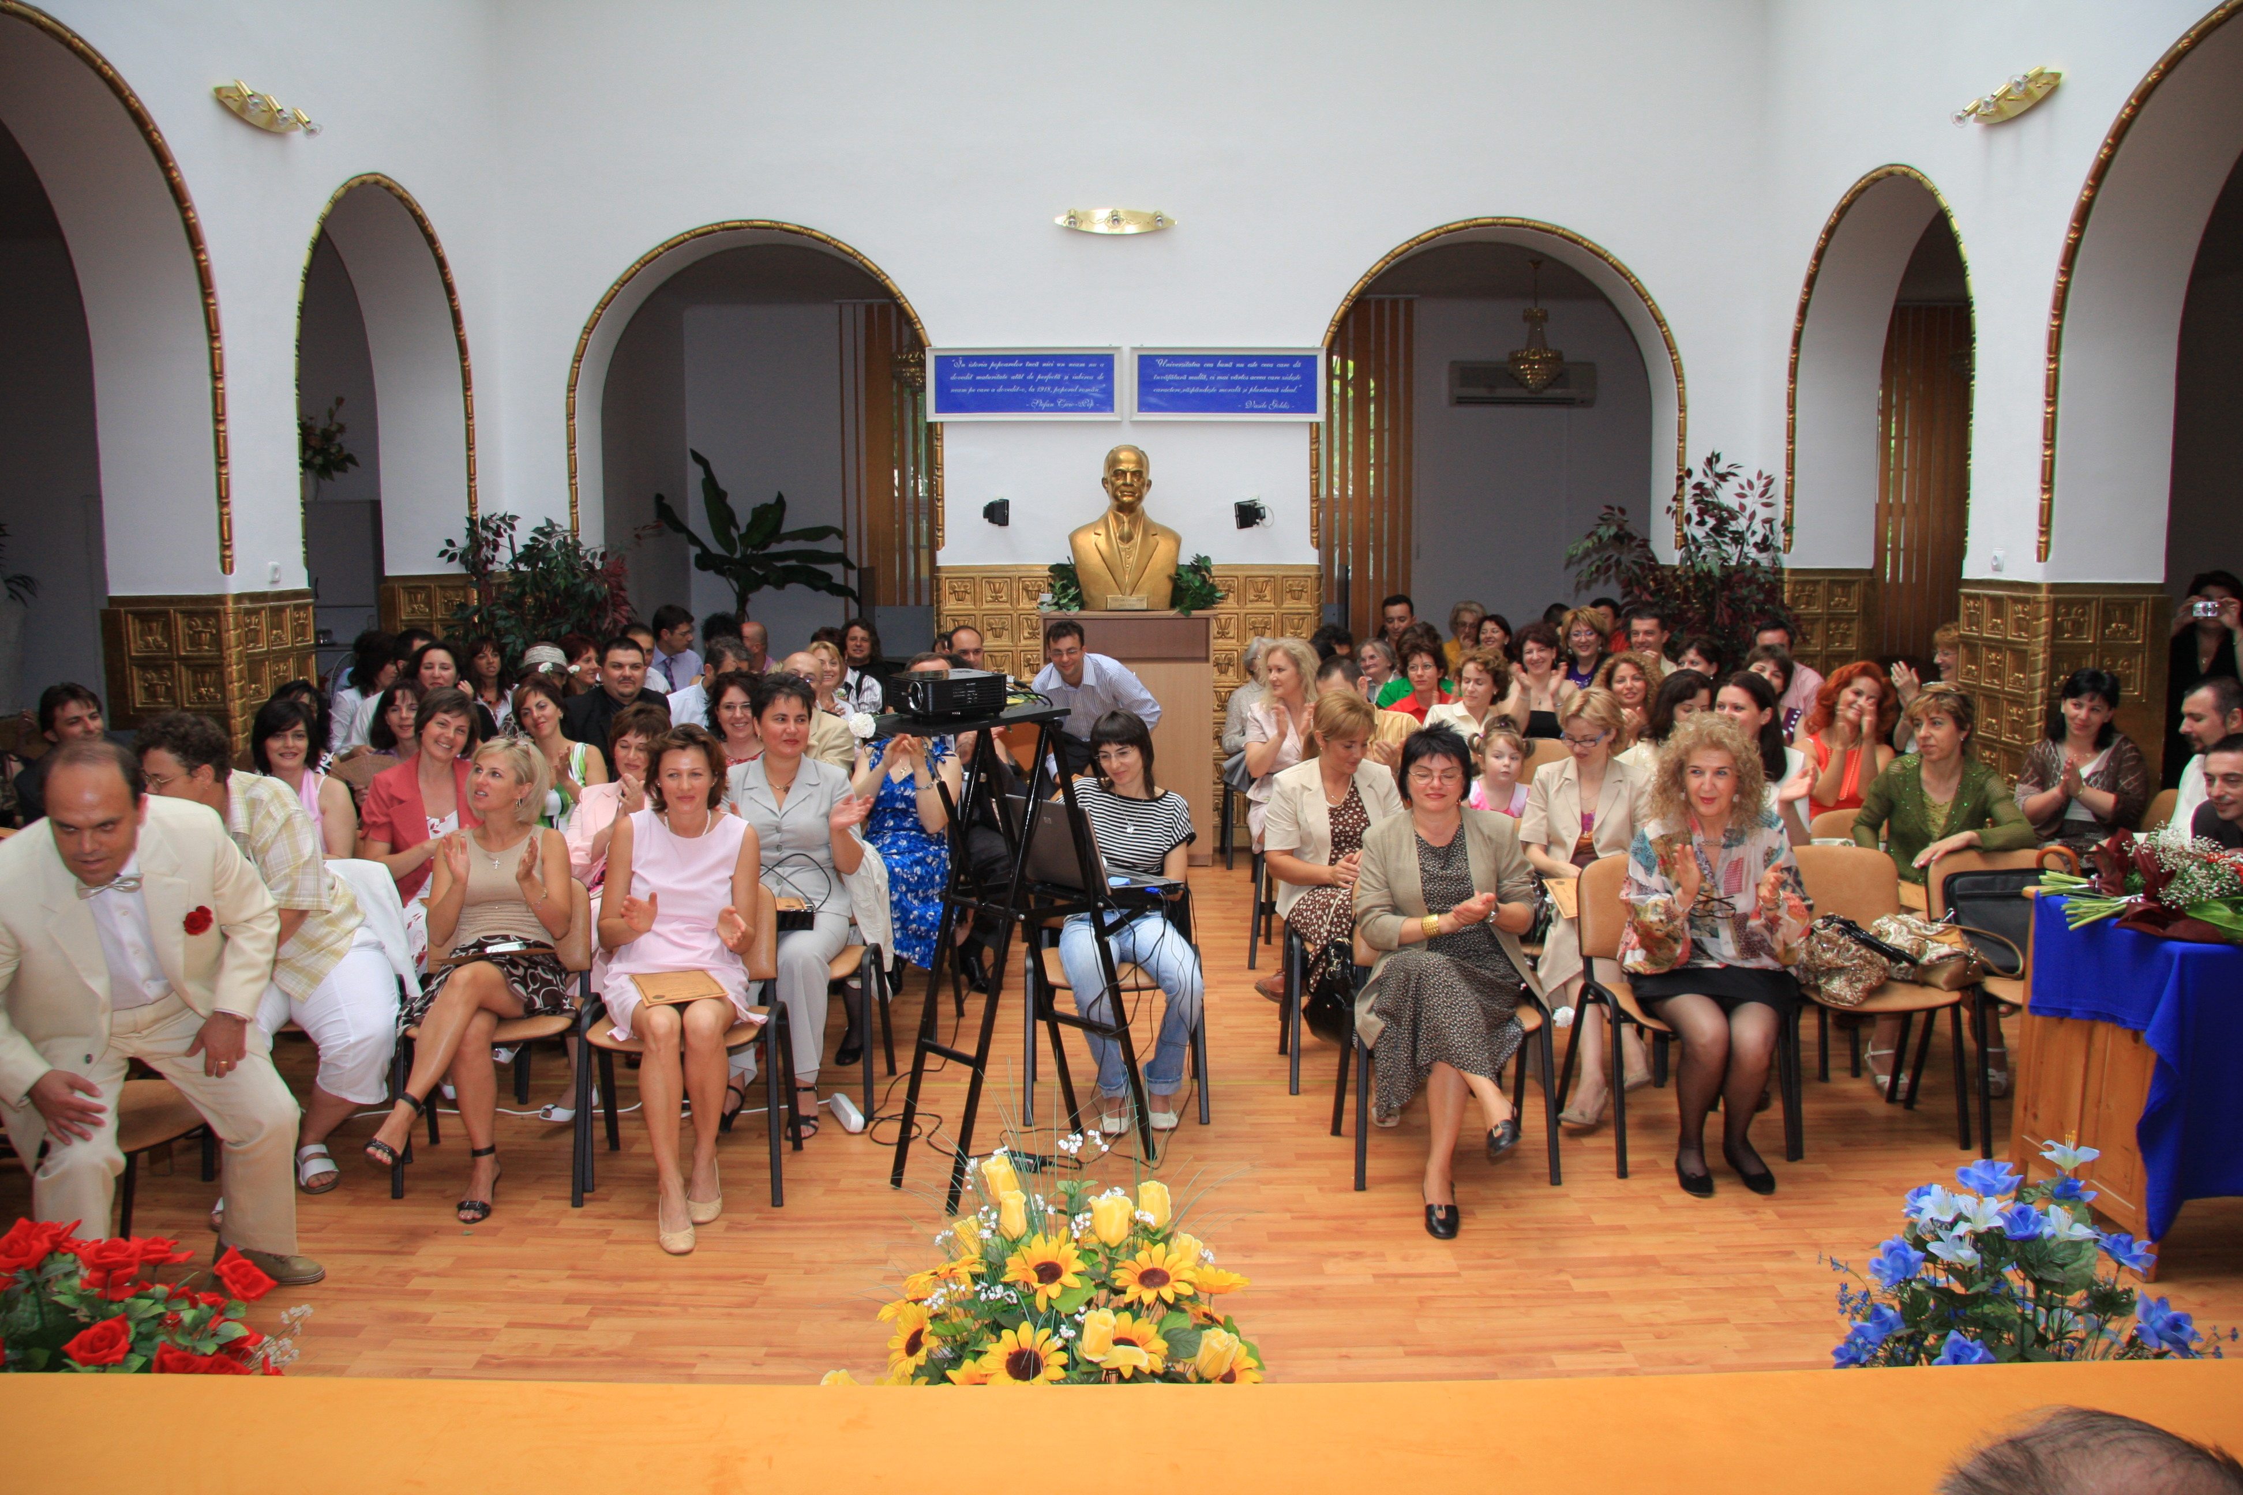

Colegii care au fost reperati si recuperati acum 10 (2008) ani si reactualizati 2018

Nr.Ctr | NUME SI PRENUME | Numar participanti | NR. TELEFON | MAIL
1 | MONICA DITA |  | 0722742337  0257/280145 | mona_nsa@yahoo.com
2 | OUATU GAGRIELA |  | O235/311319  0741180183 | doc.gabriela@yahoo.com
3 | BANU GEORGE |  | 021/3484061  0745045748 | banugeorge1974@yahoo.com
4 | MIHALACHE ANEMONA |  | 0721272316 | anemona_mihalache@yahoo.com
5 | BRUMA GABRIEL |  | 021/6426331  ACASA O744303195 | robertina.bruma@gmail.com
6 | BRUMA ROBERTINA |  | 0720333538 | robertina.bruma@gmail.com
7 | ENACHE NICOLETA |  | 0239/633440  0744645305 | tovarnacf@yahoo.com
8 | STAN STEFAN |  | 021/7603533  O722341893 | stefanstan2000@yahoo.com
9 | ROSCA MIHAI |  | 0744751830 | rosca_mihaelamohora@yahoo.com
10 | CZAHER ALEXANDRU |  | 0744501760  0261/839.114 | czaheralexandru@yahoo.com
11 | MAGUREANU ADRIAN SI MAGUREANU MARINA |  | 0721371616  0723658133 | dr_magureanu@yahoo.com
12 | BURGHIU DANIEL |  | 0744200239
13 | DORIN ORADAN |  | 0723693202  0766725883 | cristinapshy@yahoo.com
14 | CHELARU VIOLETA |  | 0724274518 | clexy2003@yahoo.com
15 | HERA ALINA |  | 0745021514 | Alina.hera@yahoo.com
16 | IORDANESCU LAURA |  | 0744424169 | romylabv@yahoo.com
17 | COTROAZA MARIUS SI MIHAELA(DOBROMIR) |  | 0723586644 | marius_cotroaza@yahoo.com
18 | TOTIR CLAUDIU |  | 0722529027  0213267016 | claudiu.totir@gmail.com
19 | DUNA REMUS |  | 0723682763  0262354950 | remusduna@yahoo.it
20 | DINU ANDREEA |  | 0721206552
21 | CORNELIAC VLAD |  |  | cvlad123@hotmail.com
22 | PAULA BAILA-CONSTANTINIDE |  | 0744693188 | paulaconst@yahoo.co.uk  Paula.constantinide@ugal.ro
23 | SLAGEAN ADINA |  |  | slagean_adina@yahoo.vom
24 | POPA HORATIU SI VIOLETA |  | 0742026970 | horatiu52@yahoo.com
25 | COJOCEA FLORENTINA |  | 0726174268  0722458640 | florentina_cojocea@yahoo.com
26 | PETRE STEFAN SI MARTA |  | 0722577059  0729600080 | marst.petre@gmail.com
27 | MARTON CAMELIA |  | 0722295409  0745255771 | macadoc@hotmail.com
28 | GEORGESCU ANGELA  LILIANA BĂDIŢĂ |  | 0014087334942 | angela_22972@yahoo.com  dan.costin@yahoo.com
29 | FLOREA TUDOR |  | 0744650442 | tudorjef1@yahoo.com
30 | LILEA VICTORITA(VIKI) |  | 0742104383  0721097494  021/6863969-acasa | lileavictorita@yahoo.com
31 | BOGDAN SPATARU |  | 0728288802  0728288812 | bogdan.spataru@fideliofarm.ro
32 | MARDARE SEBASTIAN |  | 0720540501  0763613639 | drmardaresebastian@gmail.com
33 | TUTA FLORIN |  | O745136325 | drflt@yahoo.com  yttriu@gmail.com
34 | BORLEANU MIHAI SI AMALIA |  | O723693661 | mihai_borleanu@yahoo.com
35 | BOGDAN ELIESCU |  | 0745098468  021/3302297 | bogdan.eliescu@gmail.com  bogdan.eliescu@hotmail.com
36 | CONSTANTIN ALEXANDRU SI CONSTANTIN FARAH |  | 0723539201  0722328657 | daconstantin@gmail.com  farahconstantin@gmail.com
37 | MUSTACILA ADRIAN |  | 0722388353  0745257570 | monimustacila@yahoo.com
38 | GHERMAN ALINA |  | 0368806284  0726312186 | alynamihaela2oo4@yahoo.com
39 | COJOCARU EMA SI ILIUTA |  | 0722179110  0746275872  0728972568  0745188743 | cojocaru_ema@yahoo.co
40 | SUHANIA MIHAELA |  | 0740082373 | suhania.m@gmail.com
41 | POPA OVIDIU |  | 0745389258 | ovidiupopa8@gmail.com
42 | MICU EMILIAN DORU |  | 0748179138
43 | ZAIT DANIELA-MARCOCI |  | 0741054899 | daniela_marcoci@yahoo.com
44 | FRUNZA CODRIN |  |  | codrinf@yahoo.com
45 | CLAUDIU BARBATEI |  | 0745517013 | clavbarbatei@yahoo.com
46 | MURESAN-CORDEA DANIELA |  | O741167545 | medicsef@cassalaj.ro
47 | GEO POPESCU GAROTESCU |  | 0723981404 | popescugarotescu@yahoo.com
48 | SARAMBEI CRISTIAN |  | 0744899163 | cristianrazvansilviu@gmail.com
49 | GEORGESCU ELENA |  | 0745764290  0744634173 | elenaichim@yahoo.com
50 | DRAGOIU-FERCHE CARMEN |  | 0771594676 | carmen_ferche@yahoo.com
51 | DRAGOMIR MIRELA |  | O745035043 | urzic_uta@yahoo.com  supormedicalactiv@yahoo.com
52 | DINU CIPRIAN SI DINU LILI |  | 0744605959  0745141857 | cipriancabinet1@yahoo.com
53 | MARINCA LOREDANA |  | 0726619974 | lmarinca2003@yahoo.it
54 | PUSCASU CORINA SI PUSCASU MIRCEA |  | 0745508446  0745579479 | corinapuscasu@yahoo.com
55 | BURDULOI VLAD |  | 0721345905 | vburduloi@yahoo.com
56 | VOINEA CORINA |  | 0724280422 | ioanadrianro@yahoo.com  ioanaadriana1@yahoo.com
57 | DRAGANESCU CAMELIA |  | 0721726809 | mumulusa@yahoo.com
58 | COSTIN DAN  LILIANA BĂDIŢĂ |  |  | dan.costin@yahoo.com
59 | POPA-RĂDULESCU DIANA |  |  | bogdan_diana2002@yahoo.com
60 | UNGUREANU DIANA |  | 0721353907  0235310250 | diana@inext.ro
61 | MITITELU MANUELA |  | 0722955933 | maria_gangler@yahoo.com
62 | DRAGOMIR LOREDANA |  | 0722226967 | lory_d02@yahoo.com
63 | PALCU CRISTINA |  | 0727781229 | drteaha@googlemail.com
64 | POPA ADRIAN |  | 0729989727  0744473524 | popaadrian2005@yahoo.com
65 | OFILEANU GABRIEL |  | O741180211  0235310250 | mihadudugabi@yahoo.com  cmiofileanu@yahoo.com
66 | TESCULA NICOLETA-DINCA |  | 0722589695 | nicosile@yahoo.com
67 | ZARA OCTAVIAN |  | 0788372528 | octavzod@gmail.com
68 | BOSIE MIRCEA |  | 0745097397 | mirceabosie@clicknet.ro
69 | PELLEGRINI ANGELO |  | 0722588455 | pellegrini.angelo@gmail.com
70 | STAICU VIOLETA |  | 0744629723 | manditavio@yahoo.com
71 | DUTA-GHENOIU ALINA |  | 0722506048 | am_duta@yahoo.com
72 | SANDRU ADRIAN |  | 0722317947 | adrian.sandru@gmail.com
73 | CARABAN BOGDAN |  | 0722322476 | bcaraban@yahoo.com
74 | MUNTEANU CATALIN |  | 0745217541 | catalin.munteanu@genevaromfarm.ro
75 | POPIEL ALEXANDRU SI  POPIEL PAULA |  | 0722893346 | popiel@zappmobile.ro  paulapopiel@yahoo.com
76 | BURTEL SIMONA |  | 0212116310  0723848455
77 | VALCELEAN IOAN |  | 0746257941 | ivalcelean@yahoo.com
78 | NITA SEBASTIAN |  | 0745652354 | sebinita@yahoo.com
79 | PARVULESCU CORINA SI RAZVAN |  | 0214114313  0722616865 | razvanparvulescu@yahoo.com  corinaelenap@yahoo.com
80 | SCOREC SILVIA |  | 0234370068  0723983451 | scoricica_balanta1yahoo.com
81 | SPIROIU OANA |  | 0236437926  0064211254006 | oana_s_nz@yahoo.com  bluehope1171@yahoo.com
82 | BOGDAN VALENTINA |  | 0217775820  0723445778
83 | STATE ANDREEA SI  STATE LUCIAN |  | 0751940146 | andreea.state@hotmail.com
84 | CERNESCU-RADUT PARMENA |  | 0722606877 | parmena@gmail.com
85 | LAPUSNEANU MONICA SI  LAPUSNEANU LUCIAN |  | 0721486602  0723258072 | llapusneanu@yahoo.com  lllapusneanu@yahoo.com
86 | MOISE OANA-MIHNEA |  | 0723017705 | oanamihnea@yahoo.com
87 | SORANA CAMELIA LIXANDRU DOHOTARIU |  | 0723668471  0744346360 | sorana_doh@yahoo.com
88 | DUMITRIU ANA LIANA |  | 0730002111  0213126714 | lianadum@yahoo.com
89 | RADU ADRIANA SI RADU DANIEL |  | 0729440070 | dan_radu2001@yahoo.com
90 | ORLEA GINA |  | 0723630556 | dyaconu@yahoo.com
91 | MARCU RALUCA-GHERASIM |  | 0744843785 | ralucamarcuro@yahoo.com  ralucamarcuro@yahoo.com
92 | COSTEA DANIEL |  | 0722692996 | drcostea@yahoo.com
93 | IENEA IONUT |  | 0723139692 | ienea_dr@yahoo.com
94 | NEAGU ROBERT SI NEAGU MIRELA-NITA |  | 0728100270  0728100269  021/6302708 | mirelanitza@yahoo.com
95 | TARCEVSKII RUXANDRA |  | 0723540148 | ruxandra.tarcevskii@pliva.ro
96 | GORNIC ANDREEA |  | 0723515081 | andreeagornic@yahoo.com
97 | VASIOIU RAZVAN SI RAMONA |  | 0723283174  0740202999  0740887952 | ramona_vasioiu@hotmail.com
98 | BALOK GEZA |  | 0722643336 | deckg2000@yahoo.com.ht  deckg20002@yahoo.com
99 | DRAGOMIR EMILIAN |  |  | estambert@yahoo.es
100 | APOSTOIU ADRIAN |  | 0722623354
101 | MATEI ROBERTO FLORIAN |  | 0722820341
102 | POPA MIHAI |  | 0746060323  0242/334298-cabinet
103 | PUGACEV CLAUDIU SI LORENA |  |  | pugacev_l@yahoo.com
104 | JUGRAVU AMELIA |  |  | ameliajugravu@yahoo.com
105 | POPESCU ANA PATRICIA |  | 0722507730 | appatricia@yahoo.com
106 | ISTRATE ALINA |  | 0745539637 | dave12nov@yahoo.com
107 | CRETU ROXANA |  | 0745029730 | rooxcret@yahoo.com
108 | OBILISTEANU GABRIELA |  | 0740070368  0747655128
109 | ARESAN CLEMENTINA MAGDALENA |  |  | clementina_98@yahoo.com
110 | ICHIM RARES |  | 0740159301
111 | TOMOZEI MARIA MURESAN |  | 0741128642
112 | ARGHIR ANGELA |  |  | cioncaanghirangela@yahoo.com
113 | CODOS IOANA |  |  | drioanaro@yahoo.com
114 | IFCU DORINA |  |  | dorina_micoara@yahoo.com
115 | DABULEANU AUREL |  | 0249534472  0747121620 | dabuleanuaurel@yahoo.com
116 | DIMITRIU MIHAI |  | 0788368663 | drmihaidimitriu@yahoo.com
117 | BARBU ALINA |  | 0743398904
118 | BIZERA VIOLETA |  | 0745259819 | rybana_23@yahoo.com
119 | SAFTA ANDREEA |  | 0726122304 | andreea.safta@casmb.ro
120 | ALEXANDRESCU EMANUEL  BORIS |  | 0751109322 | manu_alexandrescu@yahoo.com
121 | ISTRATE NICOLETA |  | 0729817882 | cmi_dr.virjannicoleta@yahoo.com
122 | MUNTEANU ARMANDO CLAUDIU |  | 0745825900 | amo28arad@yahoo.com
123 | BUDILEANU OANA CRINA |  | 0723008309 | oana.budileanu@yahoo.com
124 | MAGAZIN MIHAI |  | 0724319149  0314023614 | andreisci@yahoo.com
125 | GALATEANU BOGDAN |  | 0745419298 | bogdan.galatanu@gmail.com
126 | BURTEL SIMONA |  | 0212116310  0723848455
127 | VASILESCU SILVANA |  |  | info@gabrielavasilescu.com  drgabrielavasilescu@gmail.com
128 | DAMIAN CARMEN |  | O744775890 | kardam27@yahoo.com
129 | ENE MIRELA |  | 0723209236 | mirelaene@gmail.com
130 | STOICA LAURA-ION |  | 0729915235 | lauramst2003@yahoo.com
131 | DAN SI SIMONA BONDARI |  | 0741080779 | danbondari@yahoo.com
132 | IOSIF SI MAGDA KIS-MANEA |  | 0744312402 | iosifkis@rdslink.ro  iosif_kis@yahoo.com
133 | COVALIU ROXANA |  | 0723544320 | ropacoo@yahoo.com
134 | STANCIU SILVIU |  | O723217887 | silvianstanciu@gmail.com
135 | IENEA ION |  | 0723139692 | ienea_dr@yahoo.com
136 | FAUR ALIN |  | 0723886194 | alin_f32@yahoo.com
137 | NOROCEL NILAS |  | 0744779490 | norocelnilas@yahoo.com
138
139
140
141
142
143
144
145
146
147
148
149
150
151
152
153
154
155
156
157
158
159
160

